2020

Project Report

Online Tutor Booking

By:

Shranandeep Singh

**Contents**

Project Proposal 2

Goals and Objectives 2

Scope and Deliverables 2

Project Scope 2

Project Deliverables 2

Project Specification and Target Audience 2

Project Schedule and milestones 2

Resources Required 3

Functional and Non-Functional Requirement 3

Functional Requirements 3

Non-Functional Requirements 3

Project Assumptions 3

Detailed Design 4

Home Page 4

Login Page 4

Register Tutor Admin Page 4

Booking Request Tutor Page 5

Students Tutor Page 5

Tutor Page 6

Student Sign-up Page 6

Tutor Page Student View 7

Booking Request Student Page 7

Project Testing 8

User Manual 8

Introduction 8

Tutor Activities 8

Student Activities 8

# Project Proposal

## Goals and Objectives

Online Tutor Booking is an application implemented using Asp.Net. In this application there are tutors and students. Students can do online booking for tutor as per their needs. Tutors can register themselves with the application and accept booking requests from students. Tutor holds the admin rights and can register new tutor admins.Students can access the details of the tutors and can see their profile. Students can also do bookings using the application, edit, delete and access details of the booking. New students can register for the application.

## Scope and Deliverables

## Project Scope

This is a 20 days project. Using this application students can connect with professional tutors.

## Project Deliverables

|  |  |
| --- | --- |
| **Deliverables** | **Explanation** |
| Planning | This includes the planning and specification of the project. |
| Coding and Implemetation | This will show the coding and implememtation part of the project. |
| Testing and documentation | This will demonstrate how application it will be used and also the test details of the wev app. |
| Final written Report | This will provide the detailed report along with all detiails of goals, objectives, timeliness etc. |

## Project Specification and Target Audience

* + Secure login and registration by tutor and student.
  + Add, edit, delete and access details of tutors by tutors.
  + Edit, delete and access details of students by tutor.
  + Tutors can edit, delete and access details of booking request.
  + Student can access details of tutors.
  + Students can add,edit, delete and access details of the booking.
  + Target audience for this web application will be students who are looking for reliable tutors. Starting from the age of 7 to 100 and more.

# Project Schedule and milestones

|  |  |  |
| --- | --- | --- |
| Milestone | Weeks | Deliverable(s) Completed |
| Project planning | 1-2 | * Kickoff Meeting * Project Proposal * Project Definition Document * Analysis Report |
| Iteration 1 | 2-3 | * Database Design * Front End Design |
| Iteration 2 | 3-4 | * Back End – Phase 1 * Back End – Phase 2 * Final Product |
| Iteration 3 | 3-4 | * Testing * Report and final Documentation |

# Resources Required

* Windows OS 10, 4 GB RAM, Minimum i5 processor
* ASP.Net MVC and Identity Framework
* MS word, Excel for Documentation

# Functional and Non-Functional Requirement

## **Functional Requirements**

* System should allow new students to create their profile.
* System should allow all tutors to update their profile.
* System should allow the admin tutor to register new admin.
* System should allow admin tutor to add new tutors and manage the existing ones.
* System should allow tutors to access student details as well as booking details.

## **Non-Functional Requirements**

* System should be secure.
* System should run in any browser
* System should be fast and easy to use.
* System should keep personal details of the users secured.

## **Project Assumptions**

During the plan I made the following assumption for the application:

* User is available to provide the feedback for system
* Atleast one tutor and student has registered at the time of the implementation
* Admin has already registred and can register other person as admin later and no registration fee.

# Detailed Design

## Home Page

This is main page of the web application, which will be common for all users. This page contain home, tutors,Bookings, student sign-up, login and register tutor admin menu options.

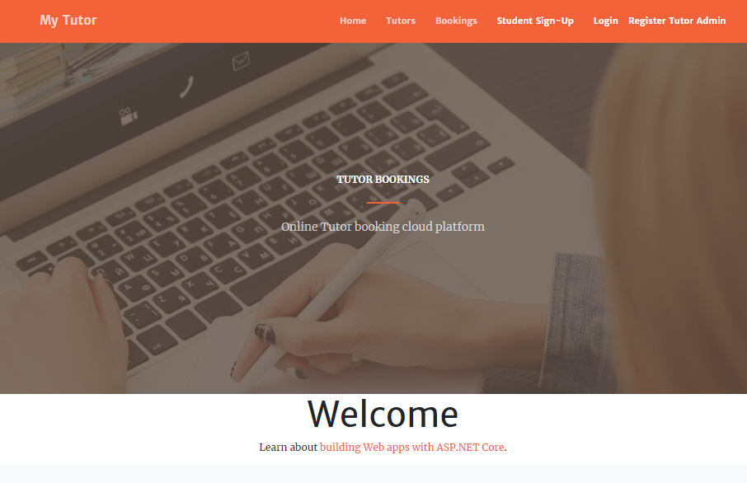

## Login Page

Login page allow register tutors and students to login into the web app.

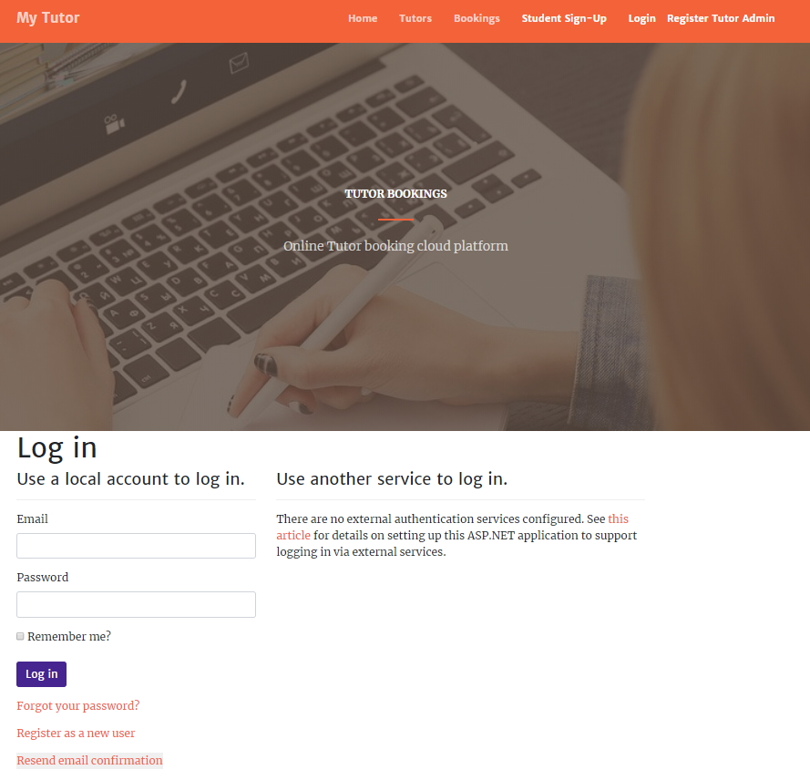

## Register Tutor Admin Page

This page will be used to register new tutor admins by the existing tutor admin.

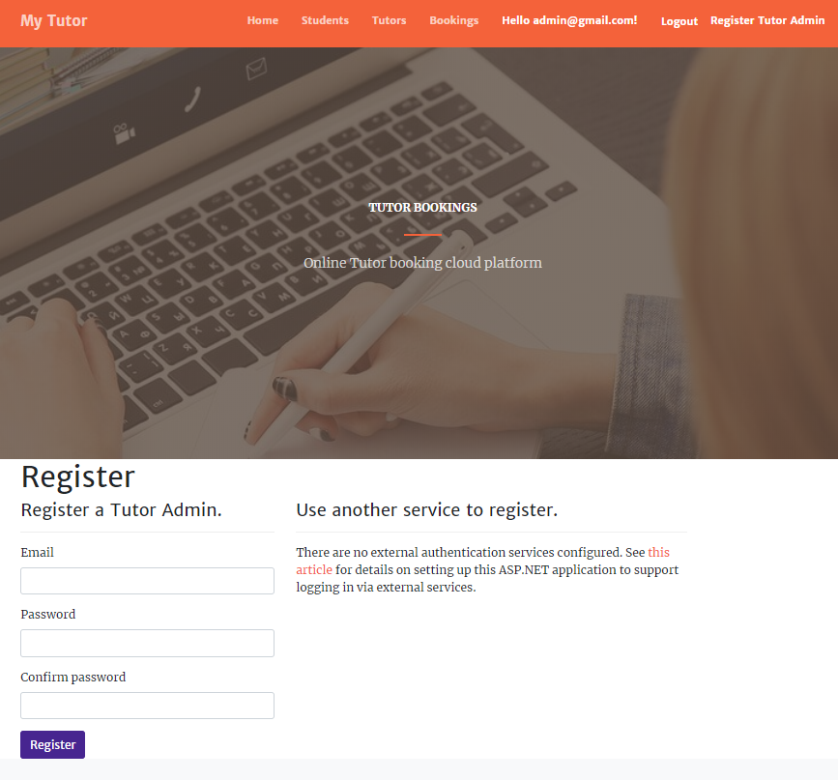

## Booking Request Tutor Page

With the help of this page tutors can edit, delete and access details of booking request.

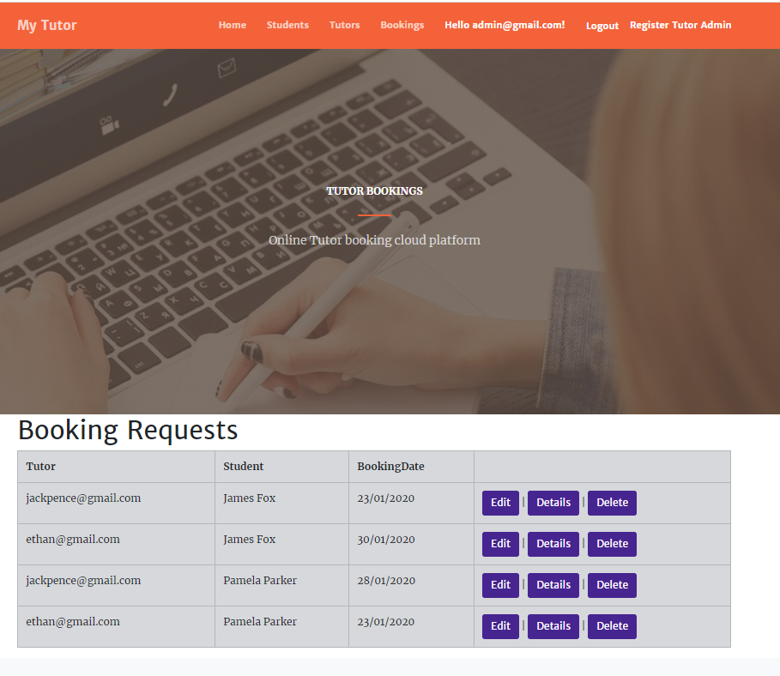

## Students Tutor Page

With the help of this page tutor can edit, delete and access details of students.

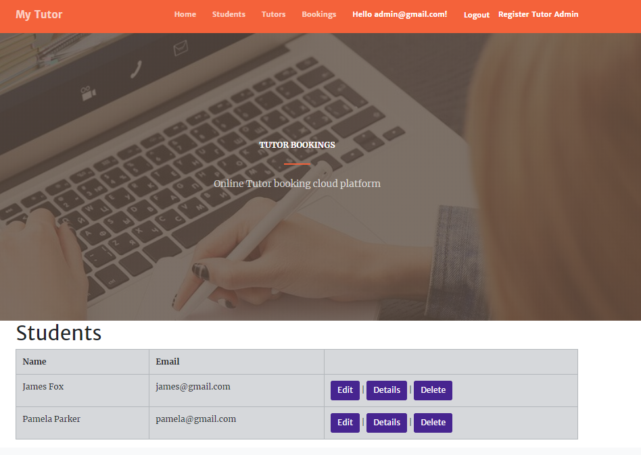

## Tutor Page

With the help of this page admin tutors can add new tutors and edit, delete and access details of the existing tutors.

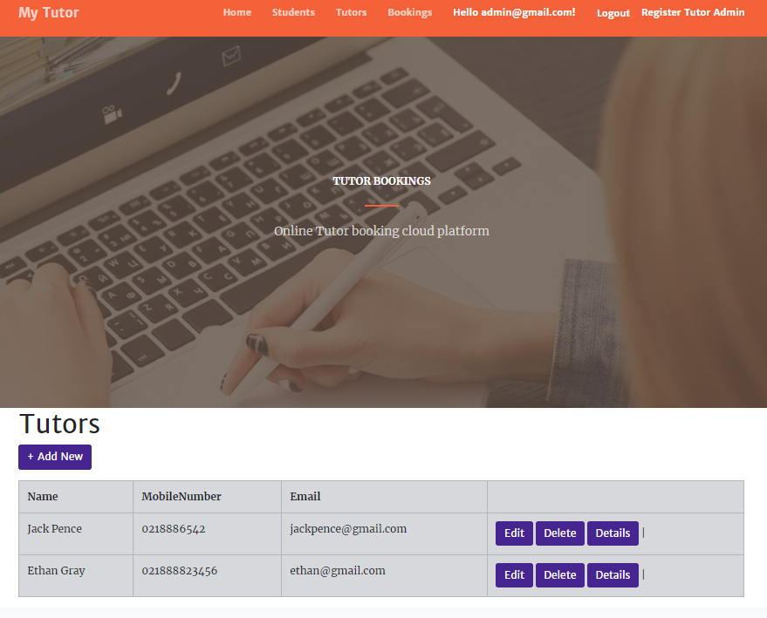

## Student Sign-up Page

With the help of this page new students can sign-up for the web application.

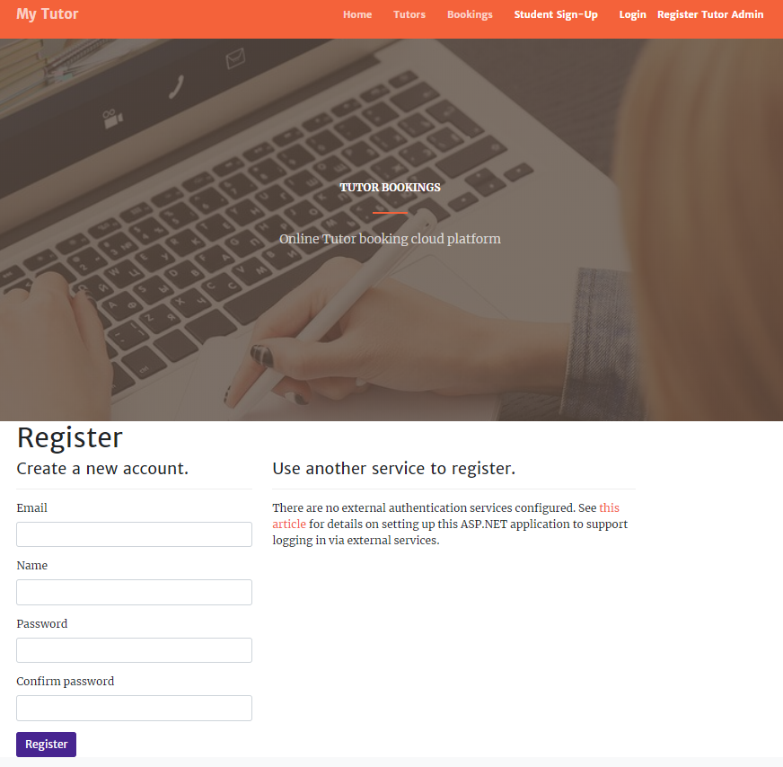

## Tutor Page Student View

With the help of this page registered students can access the details of registered tutors.

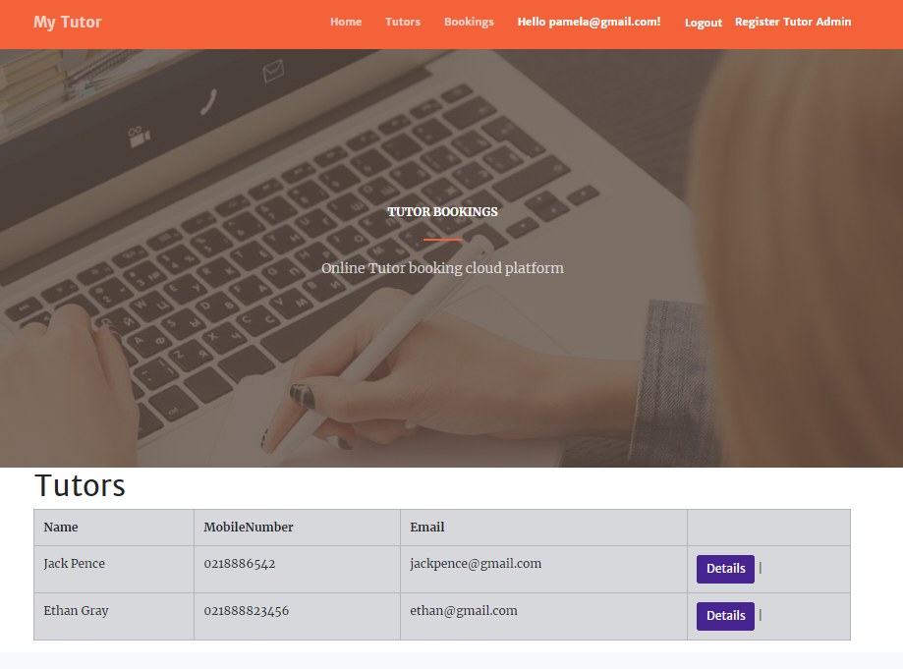

## Booking Request Student Page

With the help of this page, students can do booking and select tutor of their choice.

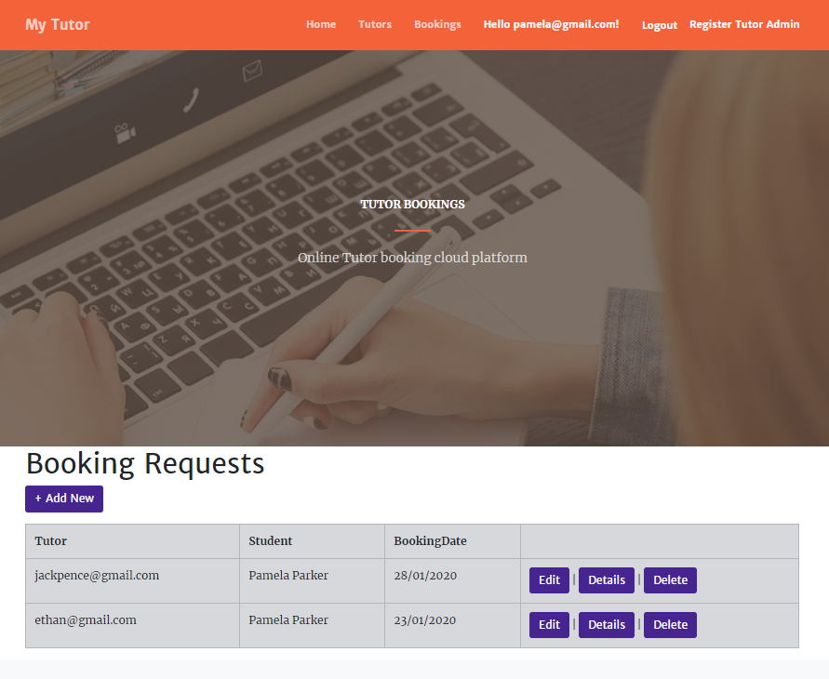

# Project Testing

The usability testing of the project is founs at [Test Plan.xlsx](Test%20Plan.xlsx)

# User Manual

## Introduction

Online Tutor Booking is an application implemented using Asp.Net. In this application there are tutors and students. Students can do online booking for tutor as per their needs. Tutors can register themselves with the application and accept booking requests from students. Tutor holds the admin rights and can register new tutor admins.Students can access the details of the tutors and can see their profile. Students can also do bookings using the application, edit, delete and access details of the booking. New students can register for the application.

## Tutor Activities

* Registration
* Login/Logout
* Add New tutors.
* Manage booking requests.

## Student Activities

* Login/Logout
* Add bookings for tutors
* Access tutor details
* Edit, delete and access details of booking.